COMMUNITY SERVICE PROJECT REPORT
ON
Awareness and Benefits of Yoga

A project Report Submitted
As part of the Curriculum for the degree of
BACHELOR OF SCIENCE
By
K.Bhuvaneswari
20440314022
Bt.Z.C Ist year
2020-2021
Under the guidance of the Mentor
C.Madhuri
Guest Lecturer in Bio-Technology


DEPARTMENT OF BIO-TECHNOLOGY
SKR & SKR GOVERNMENT DEGREE COLLEGE FOR WOMEN (A)
JUNE -2022

CERTIFICATE

This is certified that the “Community Service Project on “Awareness and Benefits of Yoga” is the bona fide work done by K.Bhuvaneswari Roll no: 20440314022 duration of one month (May-June 2022) as part of curriculum for the partial fulfillment of the requirements for the award of BACHELOR OF SCIENCE by SKR & SKR GOVT. COLLEGE FOR WOMEN (A), Kadapa, Andhra Pradesh.

Signature of the Mentor

ACKNOWLEDGEMENT

I wish to express our deep sense of gratitude and sincere regards to our institution SKR & SKR GDC W (A) NAAC B Grade Affiliated to Yogi Vemana University Kadapa for providing an opportunity to conduct Community Service Project.
I thank to Dr. P. Subba Lakshumma _{M.Com ,M.PhiL Ph.D.,} our beloved principal of SKR & SKR GDCW (A) for allowing us to pursue this project. I am also thankful to my Mentor Ms. C.Madhuri, Guest Lecturer in Bio-Technology for her valuable guidance and co-operation. My special thanks to family members, ward/Village secretary, friends and families visited for extending their cooperation in completing this project successfully.

(Roll No:20440314022)

CONTENTS

S.No | Name of the content | Page No.
1. | Work done statement | 1
2. | Log book | 2
3. | Questionnaire | 3
4. | Community Survey on | 4
5. | Introduction | 5
6. | Objective/Scope | 6
7. | Data Analysis | 7
8. | Conclusion | 8
9. | Geotagged Photos | 9
10. | References | 10

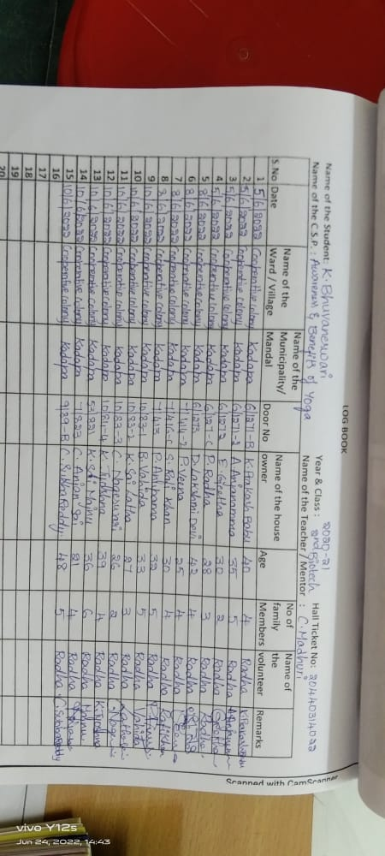

Questionnaire for CSP on students :-
1. How many students are there in the family?
2. What are they studying (with age)?
3. Do they practice Yoga?
4. Do they have knowledge about benefits of yoga?
5. What are the reasons for doing yoga?
6. Timings for doing yoga
(a)Morning (b) Afternoon (c) Evening (d) Night
7. Motivation for doing yoga?
8. Does they ever consulted a professional yoga trainer?
9. Does the yoga help them to reduce their stress?
10. How many minutes does they do yoga?
11. What are the Asanas they practiced?
12. Does they have any change after practicing yoga? (yes/no)
13. Does yoga keep them fit? (yes/no)
14. Do they practice meditation along with yoga?
(b)Afternoon (c) Evening (d) Night

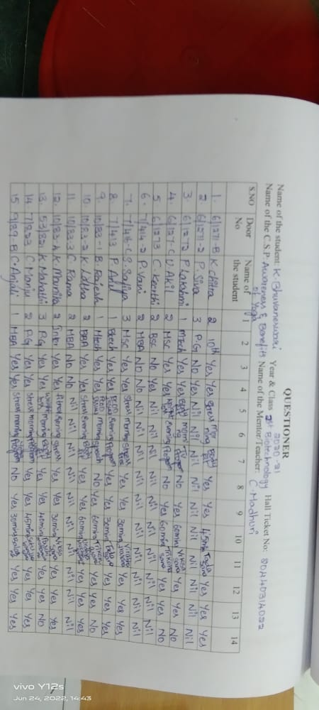

INTRODUCTION:
AWARENESS AND BENEFITS OF YOGA:
The word "yoga" means "to join or yoke together ". It brings the body and
mind together to become a harmonious experience. Man is a physical, mental
and spiritual being; yoga helps promote a balanced development of all three.
Yoga is a metghod of learning that aims at balancing "Mind, Body and
Spirit". Yoga is a practice with historicsl origins in ancient Indian philosophy.
India has a vast diversity of yoga practice, which can traced back as early as fast
5000 years when Ayurveda was being practiced. Inspite of India being the birth
place of yoga, the benefits of yoga have not reached each and every one of
us.International Yoga Day, June 21" celebrates the physical and spiritual
prowess that yoga has brought to the world stage.
The art of practicing yoga helps in controlling an individual mind,
body and soul. It brings together physical and mental discipline to achieve a
peaceful body and mind. It helps manage stress and anxiety and keeps you
relaxed. It also helps in increasing flexibility, muscle strength and body tone. It
improves respiration, energy and utility. Practicing yoga might seem like just
strectching, but it can do much more for your body from the way you feel, look
and move. Yoga incorporation of meditation and breathing can help improve a
person's mental wellbeing. Regular yoga practice creates mental clarity and
calmness, increases body awareness, relieves chronic stress patterns, relaxes the
mind, centers attention and sharpens concentration.

AIM :
To identify the Awareness and Benefits of yoga in the local population
among the public for building a healthy society.
METHODOLOGY:
Community survey and community awareness programs.
TIMELINE :
First week : Community survey. This includes the door-to-door survey along
with the collection of data in the form of questionnaire. Interacted with the
family members on the awareness and benefits of yoga schedule followed by
them.
Second week: Community awareness. Under this programme, an attempt to
create the awareness regarding the awareness and benefits of yoga program has
been made by the team members individually.
Third week: All the data collected has been compiled in the form of project
report by analising the data, recommedations & conclusions were drawn.
Fourth week: Submission of project report to the mentor and the presentation
is given to internal evaluation committee at the college level.

ANALYSIS OF THE DATA:
According to my survey, maximum students said that yoga was one of the reason for well-being of the good health and good mind, and few students did not have habit of practicing yoga.
Unlike other exercises, it proven that by doing yoga you gain energy and concentration. Moreover for practicing yoga no one needs to spend the extra money or time or space. Theybelieve that each Asana represents an aspect of themselves and as such offers a powerful doorway inward to deeper awareness.

CONCLUSION/RECOMMENDATIONS :
The current survey, which showed interesting trends in benefits about yoga as a specific discipline among a predominately young, educated and urban Indian sample.
In today's busy lifestyle with increased number of responsibilities, taking care of own health is getting difficult day by day, which is causing decreased quality of mind and body health. It helps to reduce stress among students.
So practicing yoga in capsule form, in between the busy schedule during tea break, water break or lunch break for one or two minutes can play important role in maintaining good mind and body health.
The benefit of yoga greatly contributes to oral medicine and preventing dentistry. It also increase concentration and focus on studies among students.

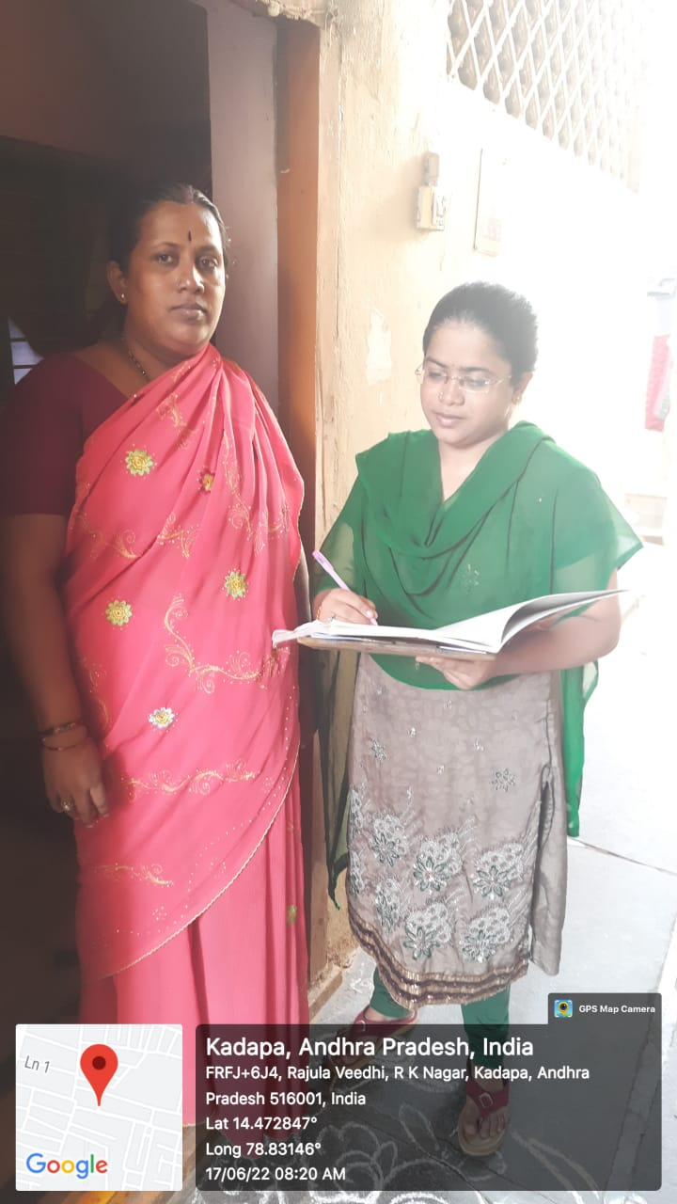
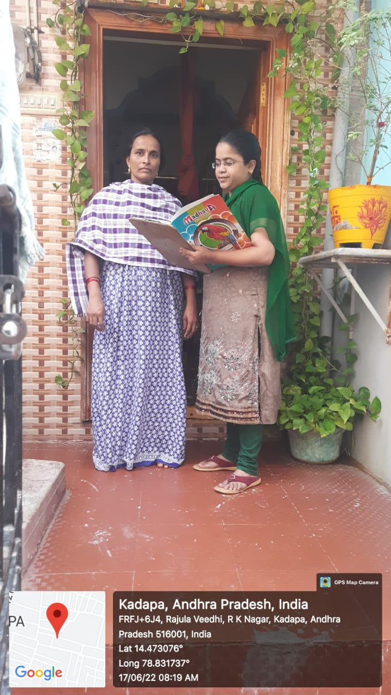

REFERENCES :
1.https://www.researchgate.net/publication/332254554 Awareness about
yoga asana and its benefits among undergraduate medical students
A descriptive study
2.https://www.researchgate.net/publication/278673574
3.https://www.medindia.net/yoga_lifestyle/yoga_importance.htm

